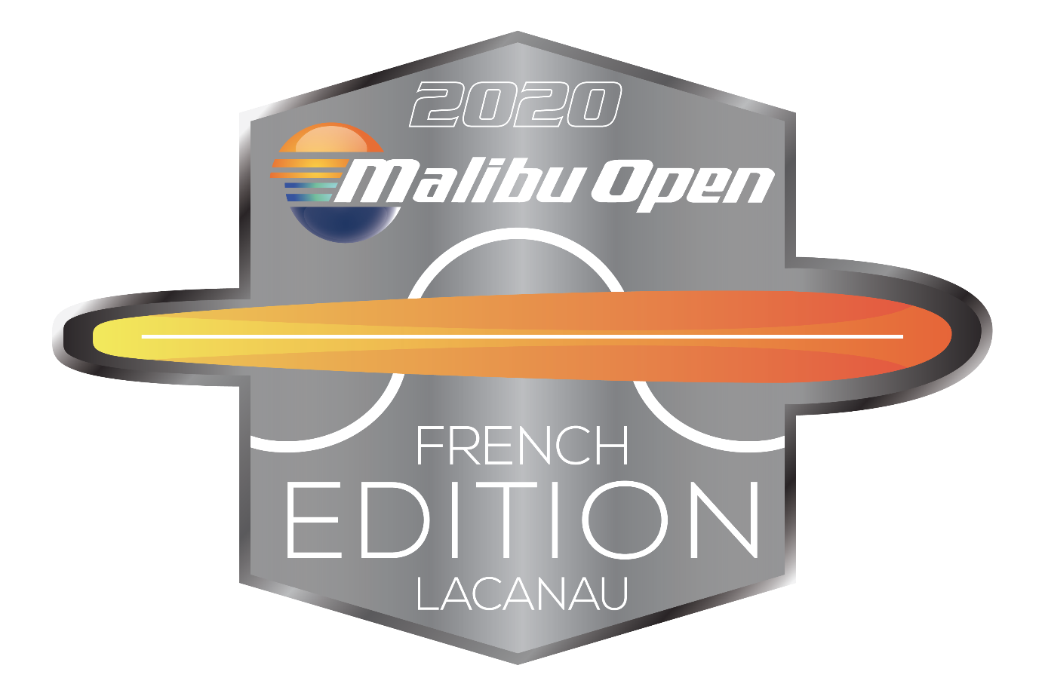

MALIBU OPEN - LACANAU - FRANCE

ELITE - RECORD CAPABILITY

CASH PRICE: $18 000 SLALOM MEN for PRO SKIERS

JUNE 21,22 and 23rd 2020 (First pro event in Europe)

FORMAT:

- 3 Rounds RC slalom for AMATEURS: 2 rounds on Sunday June 21st and 1 round on Tuesday June 23rd 2020

- 2 Rounds RC slalom for PROS on Monday June 22nd for qualification and 1 final round for cash price on Tuesday June 23rd 2020

Format for the PRO SKIERS
(Maximum of 40 skiers)
- Top 40 Men skiers in the current Elite Ranking will have prioritized entry until June 5th.
- After that, entries will be open to anyone with minimum criteria for participation of a current Personal Best of 1@10.75m for Men.
- We will accept a maximum of 40 Men
There will be 2 qualifying rounds.

Round 1
Seeded according to most recent IWWF Elite Ranking.
The top 4 Men will automatically qualify for the Head-to-Head finals, seeded at the top 4 spots.
These skiers will not have to ski Round 2, but will be allowed to if they want to.
In case of a tie for a qualifying spot, a run-off will take place, with skiers starting at the last completed pass.
In case of a tie between qualified skiers, IWSF Elite Ranking will determine Head-to-Head seeding.

Round 2
Seeded according to Round 1 results.
The top 4 Men of Round 2 will fill the remaining spots for the Head-to-Head finals, seeded at the bottom 4 spots.
In case of a tie for a qualifying spot, a run-off will take place, with skiers starting at the last completed pass.
In case of a tie between qualified skiers, results from Round 1 will determine Head-to Head seeding.

Finals
Top 8 men skier will battle in final
Payout (USD) | Pro Men
1st | $6 000
2nd | $4 100
3rd | $3 200
4th | $1 600
5th | $1 200
6th | $900
7th | $600
8th | $400
TOTAL $ 18 000

Format for the AMATEUR SKIERS
(maximum of 40 skiers across categories)
Amateur skiers will ski three rounds, with the first two rounds happening on Sunday and the last one on Tuesday morning.
The order of series will be according to age groups, so young skiers first, followed by Senior and Open. Running orders will be randomized for first round and kept equal for all the rounds.
-----------------------------------------------------------------------------------------------------------------
Entry fees:
180 € for Amateurs
280 € for Pro Men
Entry fees must be sent before deadline by Paypal or credit card
-----------------------------------------------------------------------------------------------------------------
CONTACT Information:
Géraldine JAMIN: geraldine@sports-service.fr
tel: (33) 5.56.03.09.01
Cell: (33) 6.19.69.86.10
Address:
Domaine de Pitrot
Route de l'océan
33680 LACANAU
France
DIRECTIONS & HOTELS:
The closest airport is Bordeaux Mérignac (BOD), about 45 km from the site
Although there is an official hotel for the tournament: Hotel VITAL PARK at Lacanau Ocean : http://fr.vitalparc.com/
Some houses are available on site to rent, please contact :
Géraldine JAMIN if you want more information
geraldine@sports-service.fr

